Pokémon GO Raid Battle System

Analyze Data; Write Up Findings and Recommendations Matthew Wright
11/24/17

Main Research Question
“What can Niantic do to improve the overall raid battle system experience and retain its user base?”

How the Data Was Analyzed
All of the quantitative data gathered was organized into logical groupings based on the questions asked. The majority of the quantitative data was gathered in the form of field research with a small portion of the data (3 individuals) coming from the one-on-one interviews. To obtain this data the research team traveled to locations of gyms where raids were being held and then questioned willing participants (anonymously) about their experiences playing the game and battling in raids. The intent of the field research questions was to create a quick (less than 5 minute to complete) series of multiple choice questions that would give an overview of the player’s interactions with the game and their general opinions regarding the game as a whole.

The majority of the qualitative data came from the one-on-one interviews. The one-on-one interviews were insightful and the answers received closely followed the same pattern of answers as the field research and gave a helpful perspective about the “whys” of the answers to the field research. By combining the research data and notes from each of these research methods we’ve been able to form a well-rounded look at how users are playing the game and what their likes and dislikes are about their experiences.

Research Questions, Results, and Recommendations

Q1: How often do you open the Pokémon GO app?
- ( 0 to 2 Days Per Week) = 0
- ( 3 to 4 Days Per Week) = 6
- ( 5 to 6 Days Per Week) = 8
- ( Everyday ) = 33

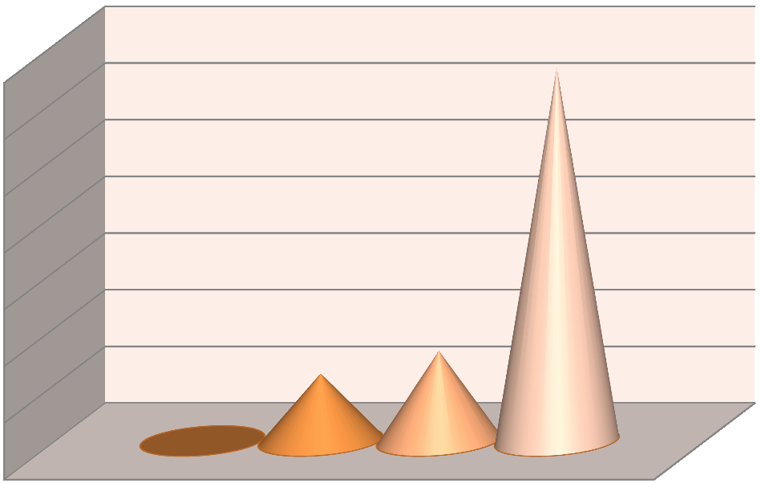
How often do you open the Pokemon GO app per week?
10

5

0
0 to 2 Days
3 to 4 Days
5 to 6 Days
Everyday
35

30

25

20

15

Findings:

The game implements a daily reward bonus for logging on and catching a Pokémon as well as spinning (going to a location of a pokestop and interacting with it) a pokestop. These daily rewards encourage players to play daily as the bonuses are multiplied each consecutive day you complete them with the largest bonuses happening on the seventh day. Because the player’s that we surveyed were all actively playing the game that may indicate why so many of them said they played daily. If we had asked the same questions on an online survey we may have gotten much different responses from more casual and rural players worldwide.

Recommendations:

- Expand and bolster the daily reward bonuses. These bonuses were universally well received by the players and by continuing to offer new rewards Niantic can strongly encourage players to continue logging on daily.
- Increase the number of pokestops and gyms in rural areas. By doing so, rural players will have a much higher chance of collecting items, daily bonuses, and interacting with gyms. This will also help establish community trust in Niantic and the game developers. If players are unable to complete raid battles they feel left out especially since the only current way to catch legendary Pokémon is by participating in raid battles.

Q2: What level is your character in the game?
  - ( Level 1 to 10 ) = 4
  - ( Level 10 to 20 ) = 6
  - ( Level 20 to 30 ) = 16
  - (Level 30 to 35) = 12
  - (Level 35 to 40 ) = 9

20 to 30
30 to 35
What level is your character?
0
10 to 20
5
35 to 40
What level is your character?
1 to 10
20

15

10

Findings:

Most of the sub level 30 players that we surveyed indicated that they were using an alternate account. The majority of the time it was a significant other or family member’s account. By using multiple phone players could give their friends or family members the chance to catch the raid bosses and gain experience even though they were unable to join the raid in person. Raid battles only occur from 6am until 7pm so a vast majority of the active raid players are busy at work.

Recommendations:

- Increase the time range of raid battles to 5am – 11pm. Since the current fastest way of leveling up characters is competing in raid battles many players feel left out if they have other engagements and responsibilities. By increasing the availability of raid battles players will be able to participate before and after their daily responsibilities.
- Boost the availability of weekend raids. Since many players have busy workweeks the weekend is one of the few times that they have to raid for an extended amount of time. By boosting weekend raids and possibly adding bonuses you can encourage 9-5ers to come out and play on the weekend.

Q3: On average, how many raids would you say you complete per week?
  - ( 0-3 Per Week ) = 4
  - ( 4-7 Per Week ) = 18
  - ( 7-10 Per Week ) = 12
  - ( 10-20 Per Week ) = 9
  - ( More than 20 Per Week ) = 4


20
15
10
5
0
10 to 20
7 to 10
4 to 7
0 to 3
How many raids would you say you
complete per week?
20+

Findings:

To join a raid, players must have a raid pass available. Players are allotted one free raid pass per day. To get additional raid passes players must either save up enough coins (100 coins) or use money ($1) to buy additional passes. This factor may be why the most players participate in 4-7 raids per week.

There was a larger majority than expected of players that said they participated in 7 or more raids per week. These players either add their Pokémon to gyms (getting them up to 50 coins per day) regularly or said that they purchased passes. Many of these players said that they bought large packs of passes whenever specials were available in the store.

Recommendations:

Create bonuses that give players reduced cost or free raid passes if they are an active player. An example may be giving players extra raid passes every 3 raid bosses they successfully beat.

Q4: On average, how long does it take for a raid to begin from the time you arrive at the location of a gym hosting a raid until you start battling the raid boss?
- ( Less Than 5 Minutes ) = 5
- ( 5 to 10 Minutes ) = 16
- ( 10 to 15 Minutes ) = 22
- ( Longer Than 15 Minutes ) = 4

Findings:
How long does it take for a raid to begin from the time you arrive at the location of a
gym hosting a raid until you start battling the raid boss?
0
5
Less Than 5 Min
5 to 10 Min
10 to 15 Min
Longer Than 15 Min
15

10
20
25

The largest factor that kept getting mentioned when asked about wait times was the use of “Discord” which is a video game centered chat app. On Discord players are able to join channels that correspond to the areas that they live near. By posting on discord when and where new raids were about to start players are able to meet up and guarantee that they would have enough players show up to battle the raid bosses. These meet-ups are usually the fastest way for players to join in raid battles.

For players who didn’t use Discord, wait times were significantly longer. Many players languished about driving to a raid in hopes of joining a battle but waiting upwards of 30 minutes with nobody arriving. The game has no internal mechanism for knowing whether you will have fellow players meet you at raids so, without the use of a chat app or Facebook group, players are at the mercy of luck on whether they’ll be able to battle a raid boss or not. This can be very disheartening, especially for more rural players, because they often must drive further than city players just to get to a raid.

Recommendations:

Create an in-game raid meet-up system. This one is tricky because you want to keep your users safe and there are a significant amount of underage Pokémon GO players. So this feature is not without legal and ethical challenges. By letting your users utilize an outside platform you separate yourself (somewhat) from blame. A chat system may not be the best option, but there is some middle ground!

If the game developers introduced a way to opt-in for raid meet-ups then you wouldn’t automatically put all user locations at risk. This meet-up system could be as simple as being able to “flag” or “ping” raid battles. A user could indicate that they will be heading to a raid battle and, by seeing other’s flags on a gym, they could more readily find battles that they have a chance of beating. A system like this could greatly increase raid participation and user satisfaction. This feature would also negate the necessity for an outside app and keep the user’s attention in-game.

Q5: In your opinion, do you think the raid battle system has improved the game?
a. ( Yes ) = 34 b. ( No ) = 13
Do you think the raid battle system has improved the game?

Yes No

Findings:

The majority of players that we asked indicated that the raid battle system has made the game more fun and has encouraged them to keep playing. There was a significant amount of players that stated “yes” but had reservations. The biggest frustrations that these players indicated was that Pokémon GO has not implemented classic Pokémon features such as trading between players and player vs. player battling.

It was interesting to note that players who stated “no” also mentioned the same issues. Many of the players that said “no” stated that they didn’t believe the game developers were focusing enough on developing these classic features and focusing too much on more lucrative features such as raids and egg hatching.

Recommendations:

Continue to expand and refine the raid battle system. The current system is currently the most popular aspect of the game but if the developers only focus on adding new legendary bosses and not new aspects of the system players will inevitably get bored. A large looming issue is the finite amount of legendary Pokémon available in the game. Once all the generations of Pokémon have been released and legendary Pokémon made available, players will become tired of the same features.

By expanding the raid system to encourage larger raiding parties is one method of retaining players. Giving bigger bonuses to larger teams is a fast and easy way to get more players to complete and fight raid battles together. Another option is to let players form teams and compete against each other to see which team can defeat the raid boss faster and give larger rewards and bonuses to the victors. By implementing small ideas like this you can keep the raid system fresh and keep encouraging players to participate in raid battles.

Q6: Do you see yourself actively playing Pokémon GO in a year’s time?
- ( Yes ) = 23
- ( No ) = 7
- ( I Don’t Know ) = 17
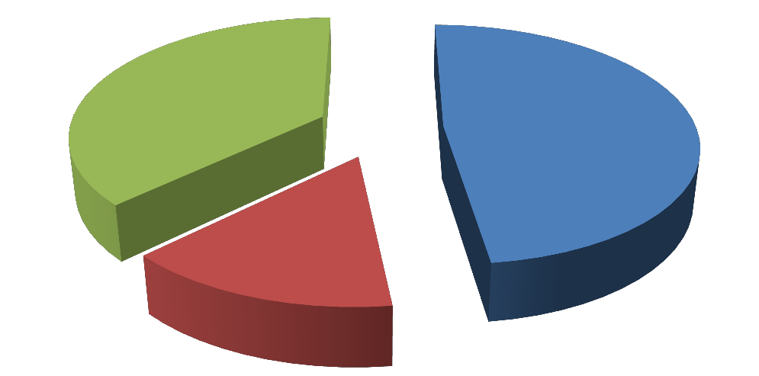
Do you see yourself actively playing
Pokémon GO in a year’s time?

Yes No
Unsure

Findings: At 24 to 23 the players that stated either “no” or “I don’t know” just barely overtake the players that indicated “yes” to whether they think they’d be playing this game in a year’s time. When asked why, many of them indicated that they would probably play until they found another “fad” game.

The players that stated they would be playing in a year’s time seemed hopeful for the game and excited to see what new features would be implemented. Many of these players indicated that they were waiting for forthcoming generations of Pokémon to be added to the game.

Recommendations:

- Implement classic Pokémon franchise game features such as player vs. player battles and Pokémon trading between players. These features would be a major draw for series purists who see the game as “Pokémon Light” and would encourage many of the active players to continue playing.
- Keep creating special events and meet-ups for players. Many players indicated that they enjoyed participating in these special events but were frustrated that these events were not near them.
- Establish better communication with the Pokemon GO community. Players want to know that their voices are being heard. By utilizing social media and in-game messages, you can establish a better relationship with players and keep encouraging them to come back.
- Give loyalty rewards to players. If a player has been active since the game’s inception, give them special rewards such as in-game clothing. These little hat-tips to active players can make a huge difference in their perception of the game developer’s attitude towards them.

